**A Web-based system designed for online interactions between doctors and the public.**

By

Jeremy Werikhe

171652

A Project Proposal Submitted to the Strathmore Institute of Management and Technology in partial fulfilment of the requirements for the award of Diploma in Business Information Technology.

Diploma in Business Information Technology

**Strathmore University**

October, 2024

# Declaration and Approval

I, **Jeremy Werikhe**, declare that this project has not been submitted to any other University for the award of a Diploma in Business Information Technology.

Student Name: **Jeremy Werikhe**

Sign: ________________________ Date: ________________________

Supervisor’s Name: **Mike Mbabu**

Sign: ________________________ Date: ________________________

# Abstract

Health services are increasingly becoming inaccessible as Kenya's population is ballooning while medical personnel are few. Many, especially those in slum areas, have to get through the burden of long wait periods, a shortage of specialists, and exorbitant fees just to get proper medical attention. Equipped with features such as video consultation, specialist referrals, and access to medications, the project henceforth aims to provide an online platform where consultation between patients and doctors will be afforded. In the main, the platform is designed to help alleviate some of the present health workloads by facilitating easier and speedier access to health services and helping to prevent avoidable hospitalizations by patients.

Prevalent situations characterizing the health sector, particularly in the rural and income-low areas, include problems associated with consultations, shortage of staff, and transport constraints. While there is development in places of alternatives such as MYDAWA, M-TIBA, and MedAfrica, their downsides include an inability to verify the prescriptions, financial abuse, and misdiagnosis. These gaps illustrate greater incorporation that should be focused on to enhance patient outcomes by simplifying the process of care, from scheduling to medication distribution to specialist availability.

I recommend developing the platform using an extreme prototyping process combined with the OOAD approach to fill these gaps. Development of the system will be done in three stages: wireframing, integrating prototype services, and full development with testing. Designing, database administration, and coding will be made by using tools such as Figma, MySQL, and Visual Studio Code. It should, therefore, be performed through informed planning, iterative prototyping, and thorough testing that guarantees security, scaling, and functionality.

# Table of Contents

Declaration and Approval ii

Abstract iii

Table of Contents iv

List of Tables vii

List of Figures viii

Chapter 1: Introduction 1

1.1 Background 1

1.2 Problem Statement 2

1.3 General Aim 2

1.4 Specific Objectives 2

1.5 Justification 3

1.6 Scope and Limitations 3

1.7 Delimitation 4

Chapter 2: Literature Review 5

2.1 Introduction 5

2.2 Understand the state of medical services in the health sector. 5

2.2.1 Hospitals. 5

2.2.2 Doctors. 5

2.2.3 Patients 6

2.3 Challenges experienced when accessing healthcare. 6

2.3.1 Transport barriers. 6

2.3.2 Shortage of personnel. 6

2.3.3 Language barrier 6

2.4 Assess existing solutions in the health sector. 7

2.4.1 MYDAWA 7

2.4.2 M-TIBA 7

2.4.3 MedAfrica 8

2.5 Conceptual Framework 9

Chapter 3: Research Methodology 11

3.1 Introduction 11

3.2 Extreme Prototyping Methodology 11

3.2.2 Prototype Development 12

3.3.1 System Modules 13

Chapter 4: System Analysis and Design 14

4.1 Introduction 14

4.2 System Analysis 14

4.2.1 Functional Requirements 14

4.2.2 Non-Functional Requirements 14

4.3 System Analysis Diagram 15

4.4 System Design Diagram 15

4.4.1 Use Case Diagram 15

4.4.2 Class Diagram 16

4.4.3 Entity Relationship Diagram 17

4.4.4 System Sequence Diagram 18

4.4.5 Database Schema 19

4.4.6 System Architecture 21

4.4.7 Wireframe 21

Chapter 5: System Implementation Testing 23

5.1 Introduction 23

5.2 System Implementation 23

5.2.1 Systems Backend Database 23

5.2.2 Systems Frontend 24

5.3 System Testing 26

5.3.1 Blackbox Testing 26

5.3.1 Functionality Testing 26

5.3.1 Unit Testing 26

5.4 Test Cases 27

5.5 Test Results 27

Chapter 6: Conclusions and Recommendations for Future Work 29

6.1 Conclusions 29

6.2 Recommendations 29

6.3 Future work 29

References 30

Appendix A: Gantt Chart 1

Appendix B: Marking Guide 3

# List of Tables

Table 1 Test Cases 27

Table 2 Test Results 27

# List of Figures

Figure 2. 1 MYDAWA 7

Figure 2. 2M-TIBA 8

Figure 2. 3 MedAfrica 9

Figure 2. 4Conceptual Framework 10

Figure 3. 1 Extreme Prototyping Methodology 11

Figure 4. 1 Use case diagram 16

Figure 4. 2 Class diagram 17

Figure 4. 3 Entity Relationship diagram 18

Figure 4. 4 System sequence Diagram 19

Figure 4. 5 Database Schema 20

Figure 4. 6 System Architecture 21

Figure 4. 7 Wireframe Homepage 22

Figure 4. 8 Wireframe patient 22

# Chapter 1: Introduction

## 1.1 Background

Because of an increasing population and a shortage of medical officers, accessing healthcare services is becoming more and more challenging. This problem is made worse by the UNDP's estimate that 400 million people lack access to basic healthcare, and 1.6 billion people reside in unstable environments with protracted crises and inadequate national health capacities (https://www.undp.org/sustainable-development-goals/good-health). The World Health Organization (WHO) reports that half of the world's population does not have complete access to basic health services, underscoring the urgent need to increase healthcare accessibility.

Neglecting this problem might have serious repercussions, such as increased death rates, shortened life expectancies, and insufficient reactions to medical crises like COVID-19 outbreaks. The need of bolstering health systems is further highlighted by the International Health Regulations, 2005, which use a grading system to assess a nation's readiness for medical emergencies. In order to address the issues of staff shortages brought on by migration and other causes, the WHO Regional Office for Africa has established the African Health Workforce Investment Charter to raise funds for improving the continent's health workforce (Africa health workforce investment forum. (2024).

Residents of underserved areas are the groups most impacted by this issue, as their health outcomes are directly impacted by their limited access to medical experts and facilities. This condition worsens already-existing health inequities, especially in low-income communities, and puts obstacles in the way of prompt treatment. The health situation is expected to intensify and endanger more lives if these problems are not resolved.

In order to address these issues, I suggest creating a web-based platform that will help patients and doctors communicate while also offering informational materials about a range of illnesses and their symptoms. By making healthcare information and services more accessible, this platform hopes to help underprivileged groups achieve better health outcomes.

## 1.2 Problem Statement

Patients should have easy access to healthcare, including the ability to visit a hospital promptly, get tested, see specialists, and get medication at a reasonable cost. The situation is far from perfect, though. According to research, patients frequently have to wait a long time for testing and results, which can take anywhere from 30 to an hour, depending on the test type (https://scholar.google.com/scholar?hl=en&as_sdt=0%2C5&q=long+patient+test+results+time&btnG=). In addition to decreasing the effectiveness of care, these delays exacerbate patient annoyance. The World Health Organization states that one of the most important components of a functioning health system is access to healthcare. Inefficiencies in this process can result in lower health outcomes, particularly for patients who need prompt interventions (Africa health workforce investment forum. (2024). People with chronic illnesses or those living in remote locations are disproportionately affected by this problem since they encounter more obstacles getting timely medicines or contacting specialists.

The availability of specialists is a significant obstacle, frequently requiring patients to reschedule appointments because of scheduling conflicts. These schedule conflicts, when coupled with prescription shortages or the requirement for special orders, further postpone treatments. Patients are unable to get care when they need it most because of this inefficient cycle. The development of digital health platforms is one suggested remedy that has the backing of numerous healthcare industry stakeholders. These systems could facilitate online consultations to determine whether a physical visit is required, expedite appointment scheduling based on specialist availability and geography, and allow patients to acquire medications online with delivery options when available.

## 1.3 General Aim

To create a web-based system to ease patient doctor interaction through online conversations.

## 1.4 Specific Objectives

1. To understand the current state of medical services in the health sector in Kenya.
2. To assess the challenges experienced when accessing healthcare.
3. To assess the existing solutions in the health sector.
4. To develop a web-based system to ease patient doctor interactions.
5. To test, implement and maintain the developed system.

## 1.5 Justification

Numerous shortcomings in the global healthcare system that leave many problems unresolved are the driving force behind the need to develop a web-based platform dedicated to healthcare. Since this initiative intends to lower barriers to getting medical treatment, it will be the best option when compared to other options. Long hospital lineups will be lessened by the website's capabilities, which include the ability for patients to book specialists when available. Doctors will thus be able to concentrate on more urgent patient problems, increasing the effectiveness of healthcare delivery.

Additionally, by giving access to patient medical records, the technology will speed up treatment in cases of emergency, such auto accidents. By doing this, medical professionals will be able to look over patient histories before to starting therapy, avoiding dangerous drug interactions or other issues. People will be able to more quickly contact with medical specialists and navigate healthcare services thanks to technology, which will eventually improve patient outcomes and the overall patient experience.

## 1.6 Scope and Limitations

To create a website that will enable patients to engage in a conversation with a doctor via video before being referred to a specialist. Furthermore, the patient will be referred to the closest hospital for additional testing if a diagnosis cannot be recognized during the video conference. Because of space constraints and security considerations, I will prioritize user privacy and data protection over adding patient records to the system.

Scaling issues could arise for the website since too many users using it at once could crash the system due to high traffic. It will also be crucial to guarantee top-notch security to shield specific patient medical records from unwanted access, but I am now unable to do this.

## 1.7 Delimitation

The website will make use of outsourced servers that can manage large traffic volumes in order to handle any potential scaling challenges, guaranteeing stability and dependability even during periods of high usage. In order to put strong security measures in place that shield patient medical records from unwanted access, we will also collaborate with expert security companies. The user experience will be improved by these tactics, which will also improve the website's security and performance.

# Chapter 2: Literature Review

## 2.1 Introduction

In order to treat and care for patients, healthcare facilities often consist of a variety of establishments that are committed to provide specific medical services. Clinics, hospitals, assisted living facilities, and rehabilitation centers are among the healthcare facilities. Every institution has a distinct function to play in relation to the patient and the issue that they are facing, which can range from diagnosing chronic illnesses to performing diagnostic testing. Each of them has specialized treatment facilities, including cancer, dental, and optical centers.

## 2.2 Understand the state of medical services in the health sector.

### 2.2.1 Hospitals.

General hospitals, which include ENT specialists, pediatricians, and surgeons, offer comprehensive care for a variety of patient conditions. Before being referred to the proper specialist, patients usually visit these facilities to diagnose and identify their medical problems. By treating a variety of medical issues and making sure patients receive the care they require, these facilities are essential to the healthcare system. Kenyatta National Hospital and Mbagathi District Hospital are two prominent examples in Nairobi that are equipped to manage a variety of medical demands.

### 2.2.2 Doctors.

In order to meet the unique needs of each patient, the medical staff at these hospitals specialize in a variety of specialties. Obstetricians and gynecologists concentrate on women's reproductive health in maternity facilities, whereas general practitioners evaluate patients and refer them to specialists. In mental institutions, psychiatrists treat mental health conditions like anxiety and depression. These professionals work together to guarantee that patients receive comprehensive care that is specific to their needs. Effective diagnosis and treatment at many healthcare facilities depend on this multidisciplinary approach.

### 2.2.3 Patients

These are the people who seek medical attention. They require diagnosis from medical personnel as per their symptoms which may require tests depending on how severe the medical condition. After diagnosis, they are given medication to alleviate their illness.

## 2.3 Challenges experienced when accessing healthcare.

There are various challenges affecting the access to health services by the general public in Kenya. A few have been expounded on as below;

### 2.3.1 Transport barriers.

Many people put off or forgo essential medical checkups because they encounter major obstacles while trying to access healthcare facilities. According to research, people find it difficult to get medical care because of the distance to medical facilities, inadequate road systems, and a lack of available transit options (ResearchGate, November 2022). People who live in underserved or rural areas, where amenities are frequently located distance from their homes, are most affected by these accessibility concerns. As a result, these obstacles may impede prompt access to necessary medical care, which could have a detrimental effect on general health outcomes and exacerbate already-existing health inequalities in the community.

### 2.3.2 Shortage of personnel.

The provision of high-quality medical care is severely hampered by the lack of both qualified and unskilled healthcare workers. Because of this shortage, current employees are overworked, which prolongs wait times and lowers patient care (ResearchGate, November 2022). Access to prompt and efficient treatments is made more difficult by the fact that many healthcare facilities find it difficult to maintain appropriate staffing levels. Improving healthcare outcomes and accessibility for marginalized groups requires addressing this workforce gap.

### 2.3.3 Language barrier

The language barrier is a major obstacle in the healthcare industry. Effective communication is hampered when patients speak languages that clinicians do not understand, which can result in inaccurate diagnoses, inappropriate treatments, and possibly worse health outcomes. This problem is especially common in places with a diverse population or when patients are traveling abroad for medical treatment.

## 2.4 Assess existing solutions in the health sector.

### 2.4.1 MYDAWA

In 2015, the Irish investment firm ION Equity developed this web application. It allows Kenyans to use a mobile phone to order medication and have it delivered to their desired location. They offer everything from pharmaceuticals to cosmetics and health care items. Create an account and then log in to make a purchase (https://kenyanest.com/top-8-best-medical-and-healthcare-apps-in-kenya/). The one problem is that there is no verification to prove if the prescription for the medication ordered is doctor approved which may lead to drug misuse.

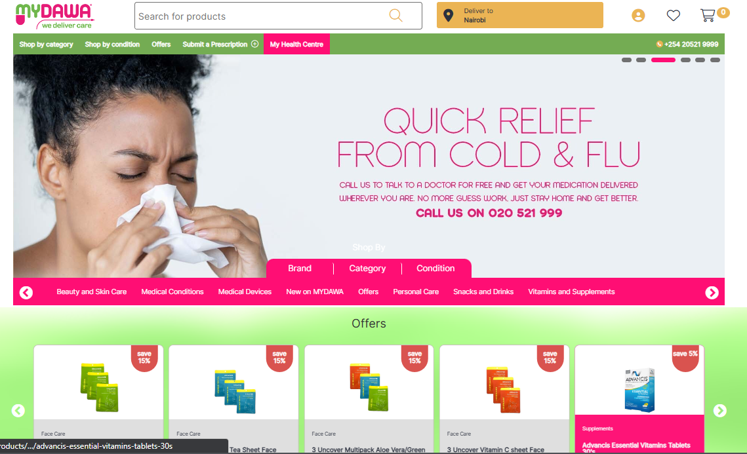

Figure 2. MYDAWA

### 2.4.2 M-TIBA

Kenyans can save, pay, or receive money using this mobile health care software, which was created and released in 2016. This helps them manage their medical costs by facilitating access to healthcare services (https://kenyanest.com/top-8-best-medical-and-healthcare-apps-in-kenya/). You can visit the mtiba.com website to learn more. This can be misused by some people as the money is used for other uses instead of medical emergencies.

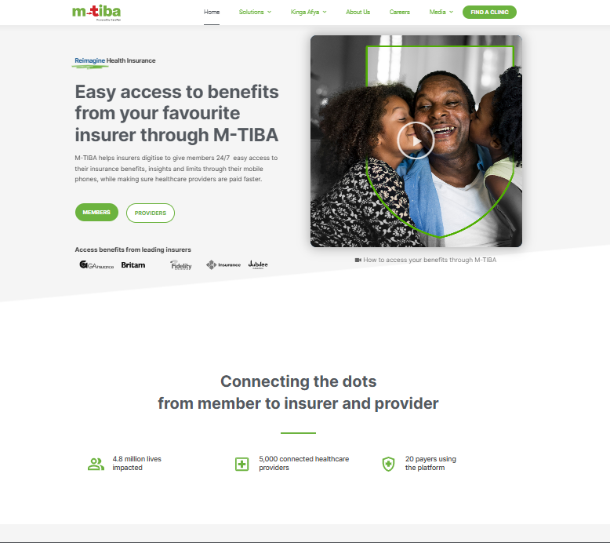

Figure 2. M-TIBA

### 2.4.3 MedAfrica

This is an application developed by Simba Technologies and was launched in November, 2011. It allows users to access medical related information such as monitoring symptoms, locating a hospital among others (https://kenyanest.com/top-8-best-medical-and-healthcare-apps-in-kenya/). This can lead to misdiagnosis of an individual as sometimes the symptoms are similar to other illnesses.

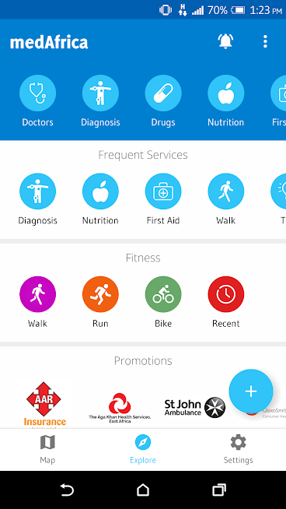

Figure 2. MedAfrica

## 2.5 Conceptual Framework

Here is a detailed explanation of how the HealthConnect system is supposed to work;

The patient accesses the website on one’s device. One then registers an account with one’s details. One then logs in a selects an available doctor and starts a conversation. Once one has received medical advice pertaining to their condition, one then proceeds to pays the consultation fee after which one signs out.

The doctor accesses the website on one’s device. One then registers an account with one’s details. The admin verifies if one is a genuine doctor. One then proceeds to log in and then wait for patient to initiate conversation. Once one is done, one can proceed to wait for the next patient. When one’s time is done, one can proceed to log out.

The admin registers details then logs in. one proceeds to monitor the network for any suspicious activity. After that, one then logs out.

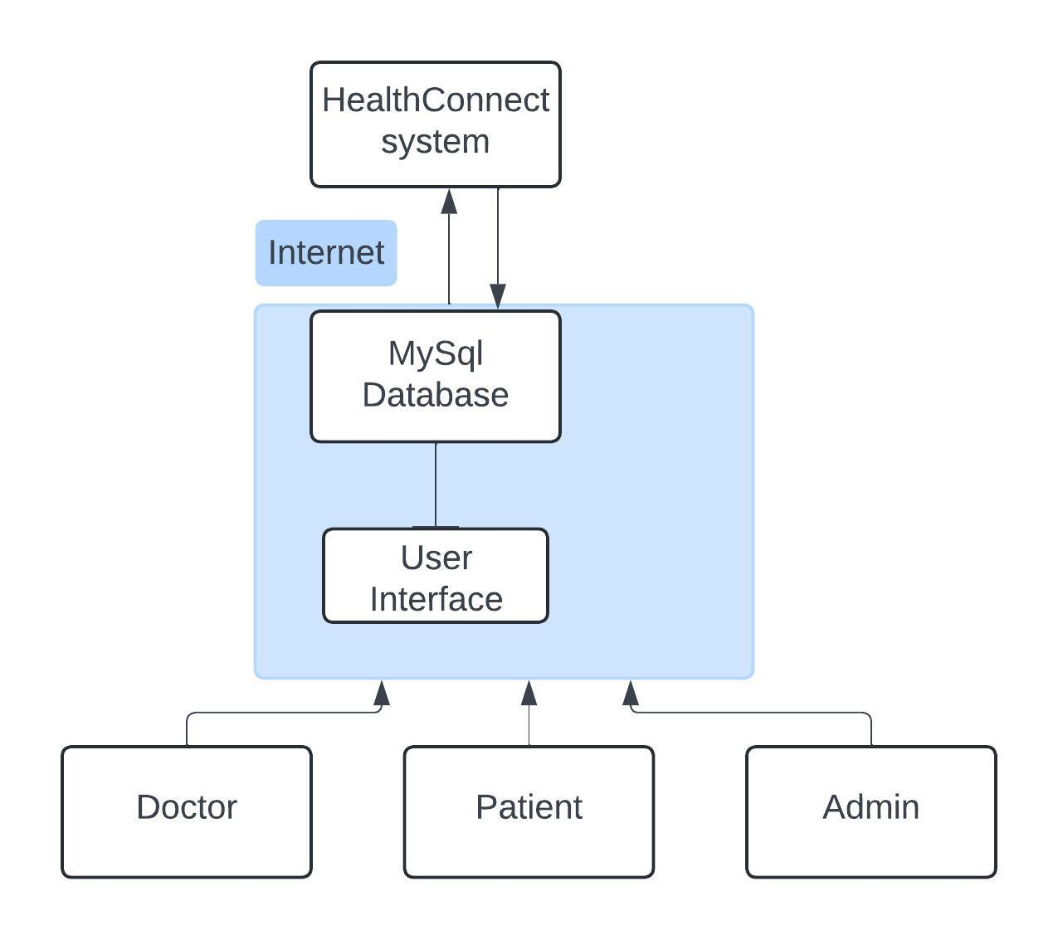

Figure 2. Conceptual Framework

# Chapter 3: Research Methodology

## 3.1 Introduction

Because it is easier to maintain, modular, and reusable, the development model that has been selected for this chapter is named OOAD (Object-Oriented Analysis and Design). The extreme prototyping method of system development, which will be used in the creation of the website, will also be covered. Along with listing and discussing the tools—such as Figma for the user interface design, MySQL for the database structure, and Lucid Chart for a use case diagram—this chapter will also go into the methods that will be employed in the system's construction.

## 3.2 Extreme Prototyping Methodology

In order to create healthcare websites where user experience and functionality are crucial, this project will use extreme prototyping, a type of agile approach, which allows for the quick and iterative construction of prototypes. Planning is done followed by three primary sequential steps in the process: First, we will create HTML wireframes to represent the presentation layer. We will then integrate these wireframes with a prototype services layer to turn them into working HTML pages. Lastly, before putting the system into use, we will code the services layer and carry out extensive testing. This strategy will guarantee that the finished product efficiently satisfies user requirements and improves usability in general.

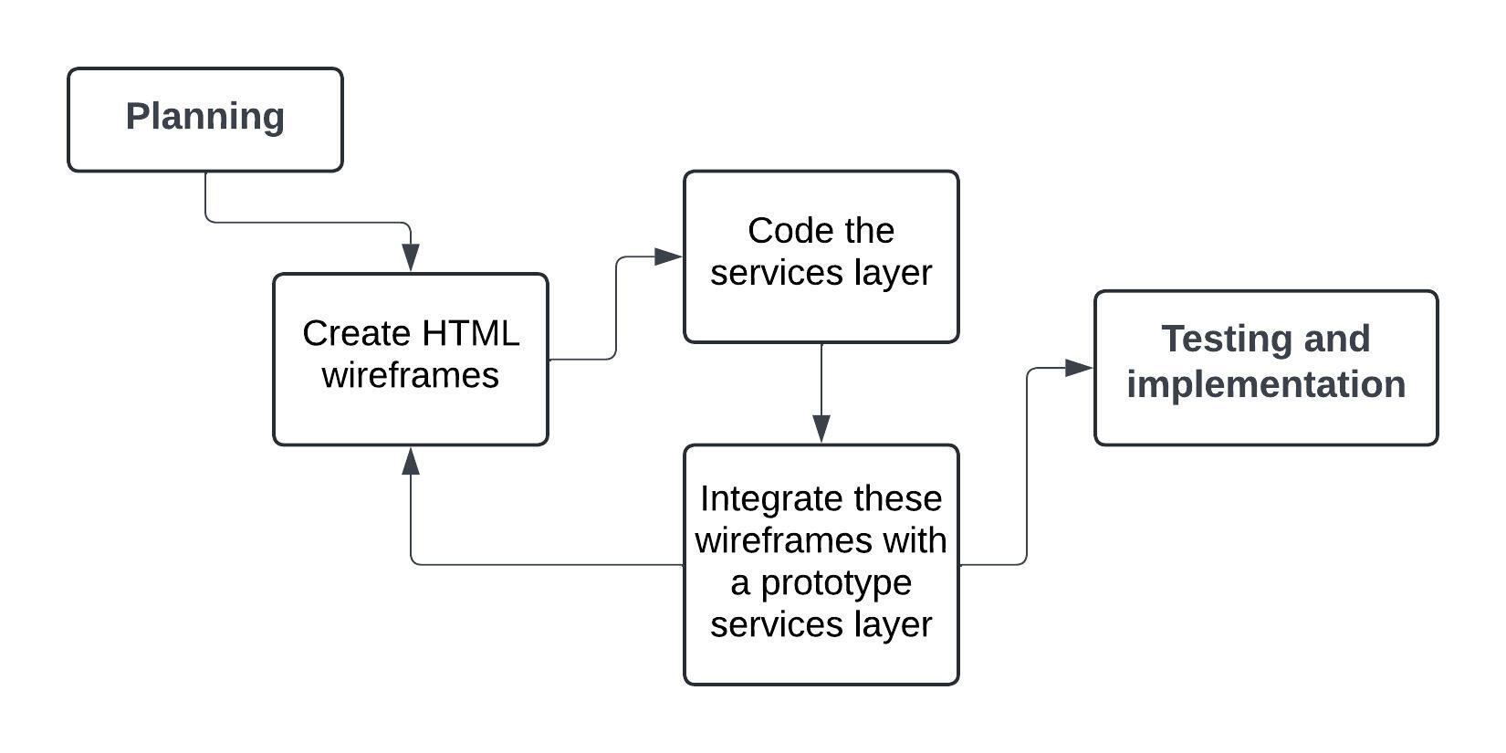

Figure 3. Extreme Prototyping Methodology

3.3.1 **3.2.1 Planning process.**

Stakeholder needs are gathered, evaluated, and documented as part of the planning process, which also establishes the project scope. Understanding basic needs, including identifying local hospitals and figuring out the availability of specialists, requires this first step. It also includes planning check-ups and making sure that project needs are approached thoroughly. All things considered; careful planning lays the groundwork for a project's successful completion.

### 3.2.2 Prototype Development

Creating a prototype that accurately depicts the system is the first stage in extreme prototyping. A functional model with limited functionality is then created and presented to stakeholders. Stakeholders then assess the prototype to look for any missing parts. Depending on feedback, changes are done as needed until the finished prototype satisfies client requirements. This iterative process keeps going until the buyer approves the prototype, at which point the development phase starts. Here also, one will sketch the UML diagrams i.e. use case diagrams, class diagrams among others so as to get a sense of direction when creating a system.

**3.2.3 System Development**

We will begin working on the real system after the web-based system prototype is finalized. Since this is a web-based system, we will use HTML. The front end and back end will be designed and developed using Figma, and the database will be MySQL. Because Visual Studio Code is so lightweight and adaptable, it will be utilized to code and develop the system.

**3.2.4 Testing**

To evaluate the system's functionality, I will use boundary values and equivalency classes in my black-box testing. In order to evaluate the system's implementation, I will also conduct white-box testing utilizing data-flow testing.

**3.3 Deliverables – System Architecture and Modules**

### 3.3.1 System Modules

User Registration Module; Here the user can register their details such as name, id number, etc. This depends on the user as the admin, patient and doctor will have different registration modules.

Payment Module; Here the user can make a payment.

# Chapter 4: System Analysis and Design

## 4.1 Introduction

It summarizes the design and system analysis of the suggested platform, and it has provided an elaborative explanation of the system architecture for further understanding. The architecture of the system, including its structure, behaviour, and views, will be described using different models, which include use case diagrams, class diagrams, sequence diagrams, activity diagram and database schemas that map out the flow of data, inputs, and outputs. It also gives an in-depth knowledge of how the system works, showing how data is inputted, validated, processed, and then represented.

## 4.2 System Analysis

### 4.2.1 Functional Requirements

The fundamental behavior of the system is defined by the functional requirements. In essence, these are the functions or services that the system provides.

The requirements delivered by this system are as follows:

1. Doctors and patients are able to create accounts.
2. The system develops a mechanism to authenticate its users.
3. Admin can view and manage account created by doctor and patient.
4. The admin can freeze a doctor’s account if any issue is discovered with their credentials.
5. The patient is able to select a doctor and make payment.

### 4.2.2 Non-Functional Requirements

System characteristics like security, dependability, performance, maintainability, scalability, and usability are defined by non-functional requirements. They act as limitations or restrictions on how the system is designed across the various backlogs.

1. Security: The system verifies the identity of every user and protects the data of all patients and doctors.
2. Availability: As long as they have an internet connection, patients and doctors can access the system at any time and from any location.
3. Usability: The system's user-friendly interface makes it simple to use.
4. Maintainability: To minimize or prevent downtime, the system is routinely maintained.
5. Performance: The system should be able handle a high volume of users at the same amount of time as well as being fast enough to react to user actions.

## 4.3 System Analysis Diagram

System analysis diagrams are diagrams used to depict early models of system behaviour and components, high-level business processes. They provide a practical way of recording the fundamental requirements and features of the system.

A system diagram is a diagrammatic representation that shows a system, its constituent components, and how they function together. All the vital information regarding a system's design can be recorded in the supporting documents with the help of diagrams.

## 4.4 System Design Diagram

A system design diagram is an example of a system, its components, and the interaction between those components. It can document all the important information about the design of a system, with the help of supporting documentation.

### 4.4.1 Use Case Diagram

The use case diagram of the healthcare web application system illustrates the relationship between three major actors: the patient, physician, and administrator. Following the medical advice, in this system, a patient registers, logs into the system, selects and consults a doctor, pays the consultation fee, and then logs out. The doctors also, after administrative endorsement, register and log into the system, await the consultations of the patients, answer questions, and then log out at the end of their availability period. Also, the administrators can view system activities before logging out for security reasons, ensuring user legitimacy and network security. Arrows in the diagram show the operational sequence and points of interaction for each user role, showing the directed flow of messages between these actors and the system.

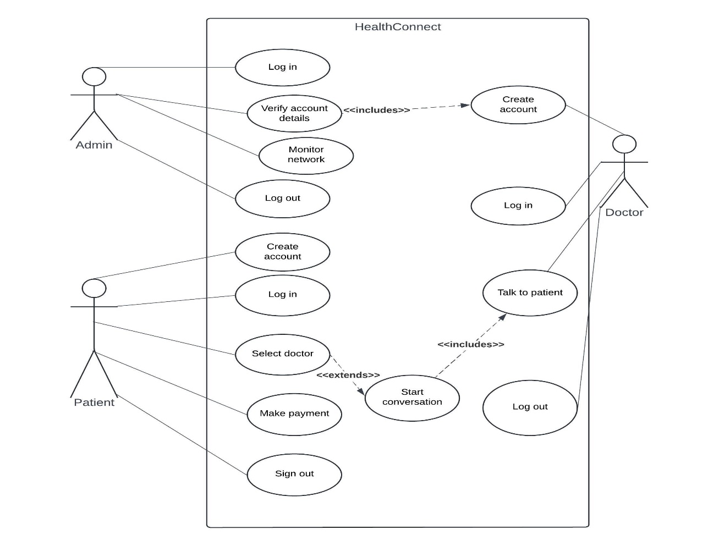

Figure 4. Use case diagram

### 4.4.2 Class Diagram

This class diagram describes the main responsibilities of some of the most important entities in the health service web application: namely *Patient*, *Doctor*, and *Admin*. The Patient class allows users to register, log in, view doctors, initiate chats, receive medical advice, pay consultation costs, and log out. The class *Doctor* creates an account, logs in after verification, holds a conversation with patients, and then signs off at the end of the shift. In the class *Admin*, it includes handling registration, login, verification of doctors, and monitoring of the security system.

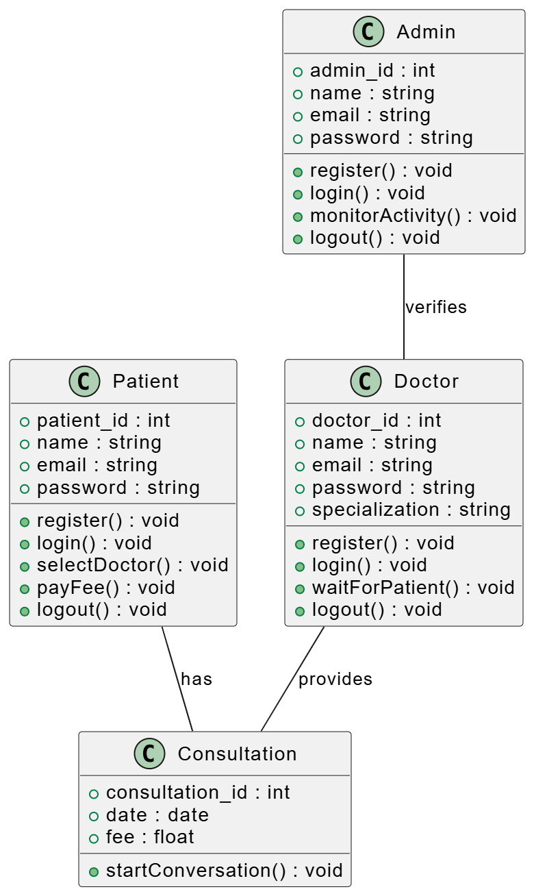

Figure 4. Class diagram

### 4.4.3 Entity Relationship Diagram

The entity-relationship diagram shows the interactions of three main entities: Patient, Doctor, and Admin. The patient entity interacts with the system for registration, login, doctor selection, consultation request, charge payment, and logout. After the admin's verification, the doctor entity will log in, wait for the initiation by the patient, conduct consultations, and sign out. The activities such as registration, login, monitoring of network behaviour, confirmation of doctors, and log out are done by the admin entity. The relations are depicted by arrows that show function sequences and message flow between these entities.

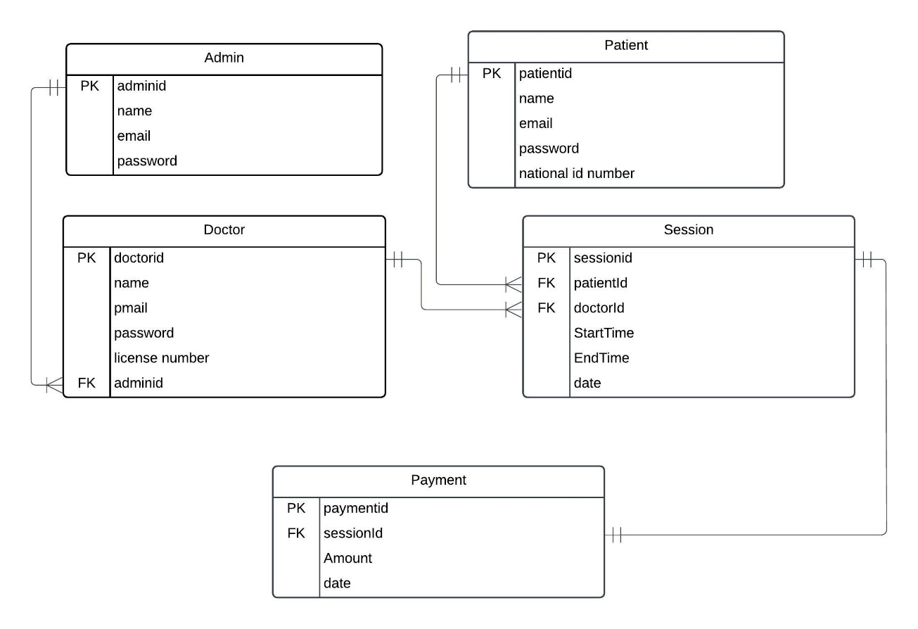

Figure 4. Entity Relationship diagram

### 4.4.4 System Sequence Diagram

The sequence diagram of the system design describes how the interactions between patients, physicians, and the administrator interact over the healthcare application. After registering and logging in, a patient selects an available doctor, initiates a conversation, and following medical advice, concludes the session by making the consultation fee payment and then signs off. Administrative verification followed by registration, the doctor waits for the consultations initiated by the patients. The doctor serves the patient and then logs out once all sessions are completed. Meanwhile, after registration and login, the administrator checks for abnormal behaviour of the system and eventually ends the session once all checks are completed. Arrows in this diagram show the flow of messages between the entities and sequential operation of the system.

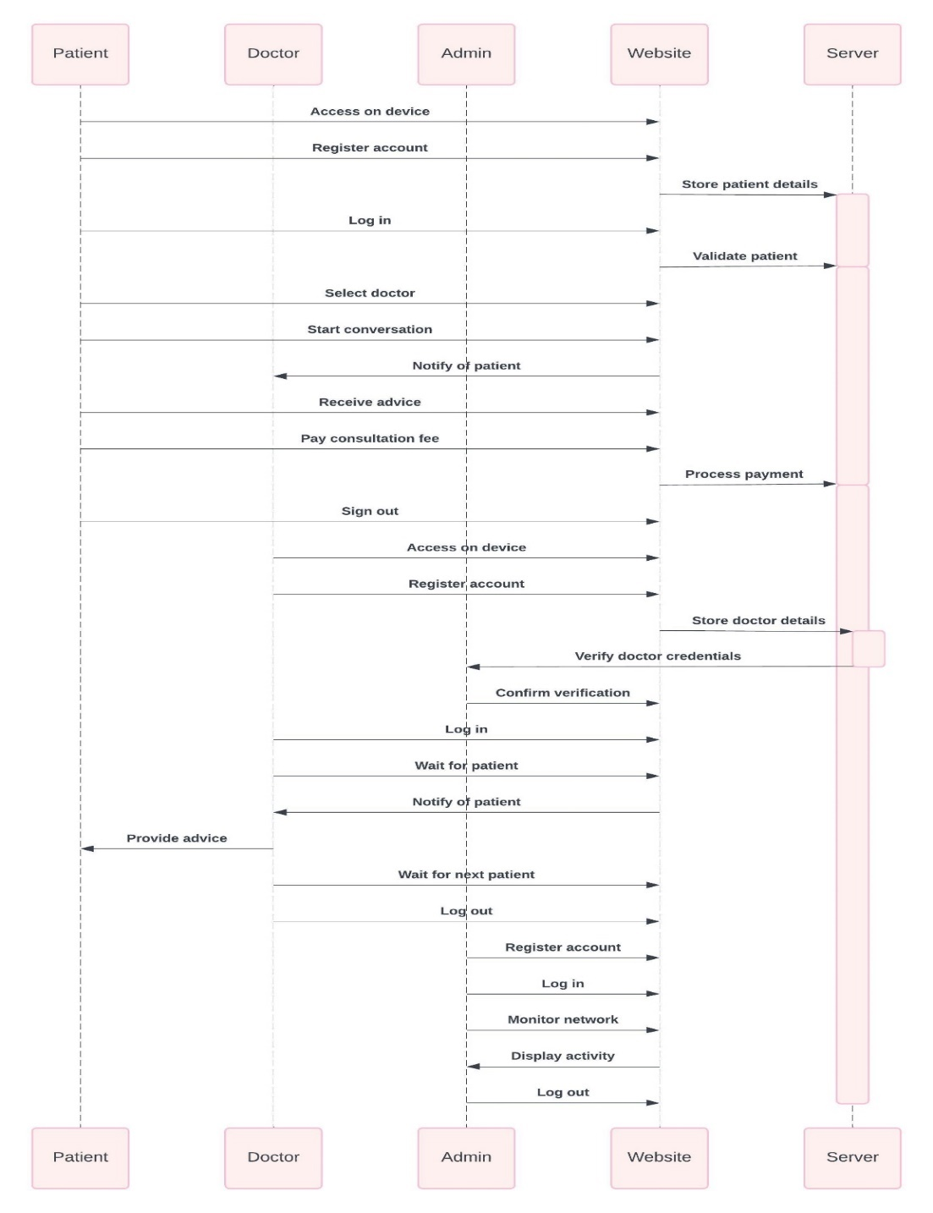

Figure 4. System sequence Diagram

### 4.4.5 Database Schema

The MySQL database schema for the health services application would include the respective tables for *Patient*, *Doctor*, and *Admin*, which maintain information relevant for that particular user type, such as accounts, log-in details, and status. While *Doctor* data will maintain records of status such as registration and verification details coming from the *Admin* level for the purpose of validation of legitimacy, personal information will be recorded on the *Patient* table. The doctor-patient interactions will be kept in a separate table called *Session*. Another database that may be used is the *Payment* database, which would manage the records of payments regarding session costs. The *Admin* table would host login information and tracking logs for network security and monitoring. Accordingly, relationships between these tables will ensure smooth function flow: secure registration, initiation of conversation, fee transaction, and logout by users. For example, the *Session* table connects *Patient* to *Doctor*, and the payment information is attached to it.

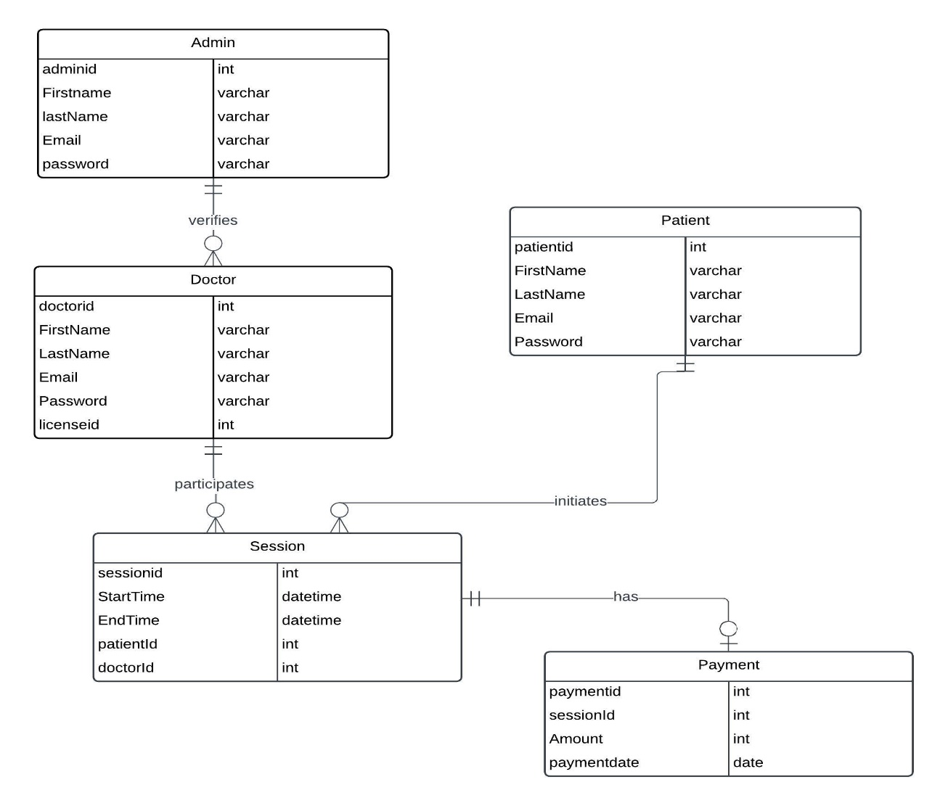

Figure 4. Database Schema

### 4.4.6 System Architecture

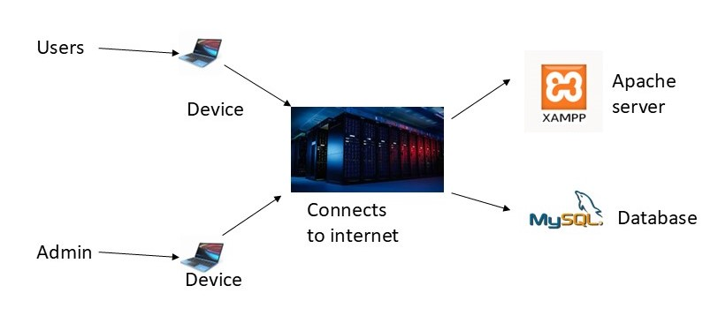

Figure 4. System Architecture

### 4.4.7 Wireframe

A wireframe is a visual scheme that describes the basic architecture of a website, putting emphasis on interface layout, content priority, and space allocation. It is a basic guide that enables effective planning of user interaction and the arrangement of content.

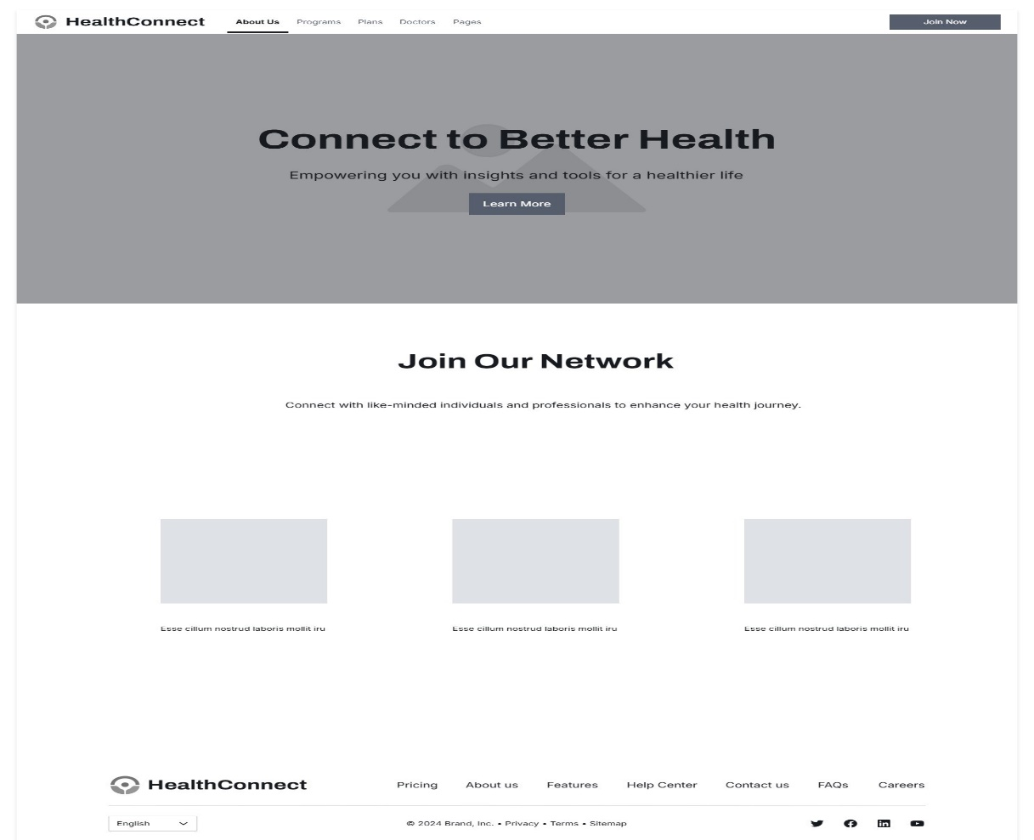

Figure 4. Wireframe Homepage

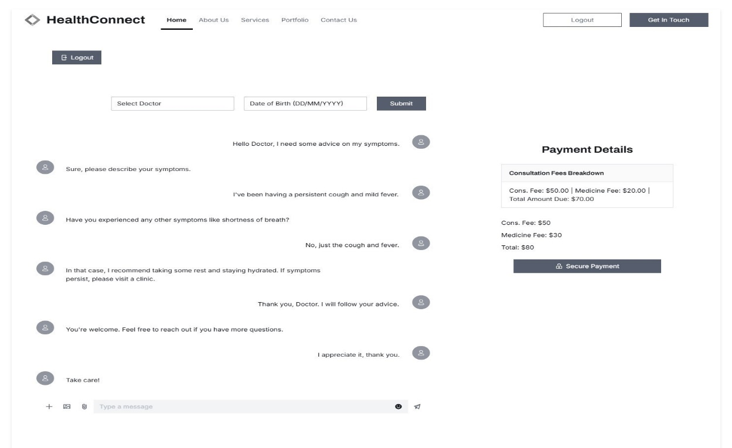

Figure 4. Wireframe patient

# Chapter 5: System Implementation Testing

## 5.1 Introduction

This chapter describes the early development of the system, putting emphasis on how the different parts of the system were integrated to provide a workable system. It also covers the test cases that were employed and the ensuing results.

## 5.2 System Implementation

In designing the system, the used programming language was PHP, implemented in the Visual Studio Code environment. CSS was employed to ensure items were all styled the same throughout every different page. The system utilized MySQL for storing data about texts and images. After creating registration and login pages that can manage password and email authentications, the basic structure of the system was done.

### 5.2.1 Systems Backend Database

As shown below, the backend of the system manages the fundamental logic that drives the main features of the healthcare platform.

1. Admin database   
   The screenshot below shows where admin data is stored when an account for the admin is created.  
   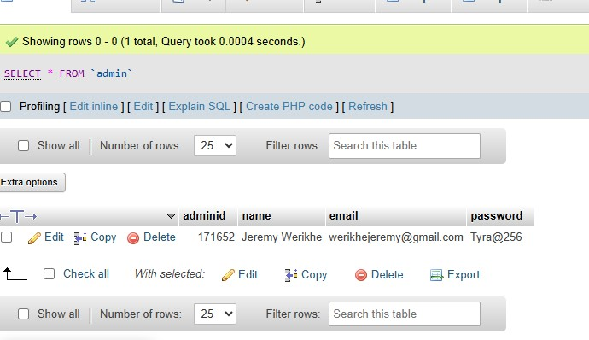
2. Patient database  
   The screenshot below shows where patient information is stored after an account is created.  
   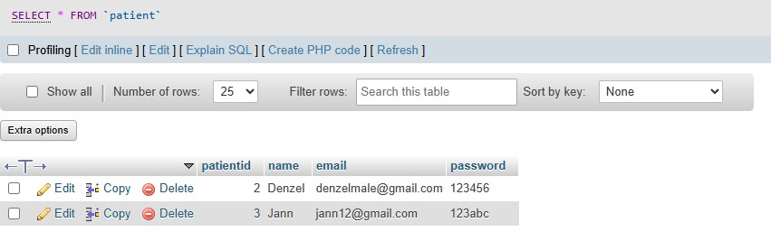
3. Doctor database  
   The screenshot below shows where doctor information is stored after an account is created.  
   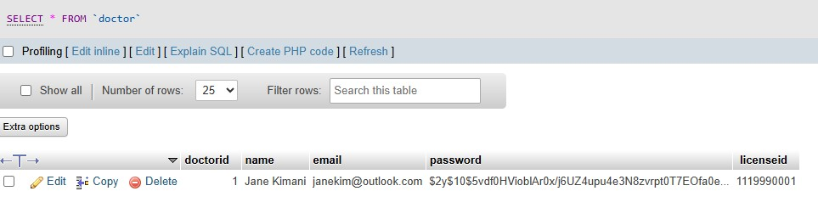
4. Login database  
   The screenshot below shows the login database used when creating the system.  
   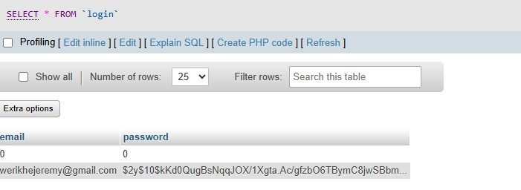

### 5.2.2 Systems Frontend

The logic in charge of creating and executing the healthcare platform's user interface, as described below, is included in the system's frontend.

1. Homepage  
   The homepage interface's design, created with HTML and CSS, is displayed in the screenshot below.  
   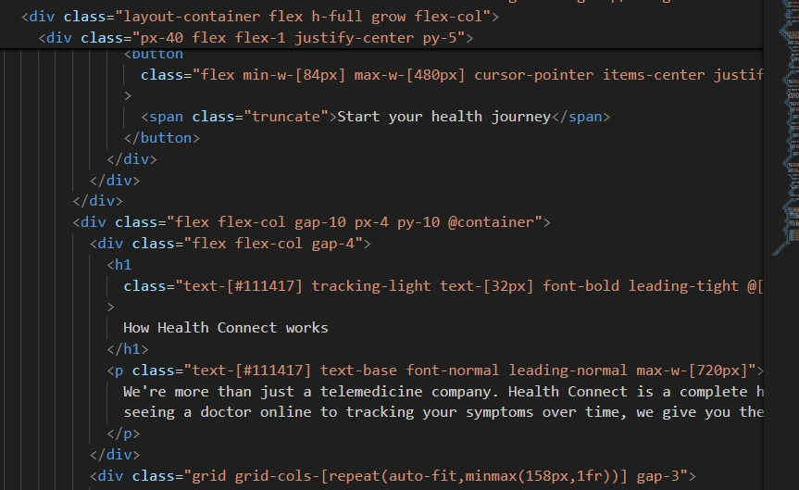
2. Patient dashboard  
   The user interface of the patient dashboard, which was made with HTML and CSS, is seen in the screenshot below.  
   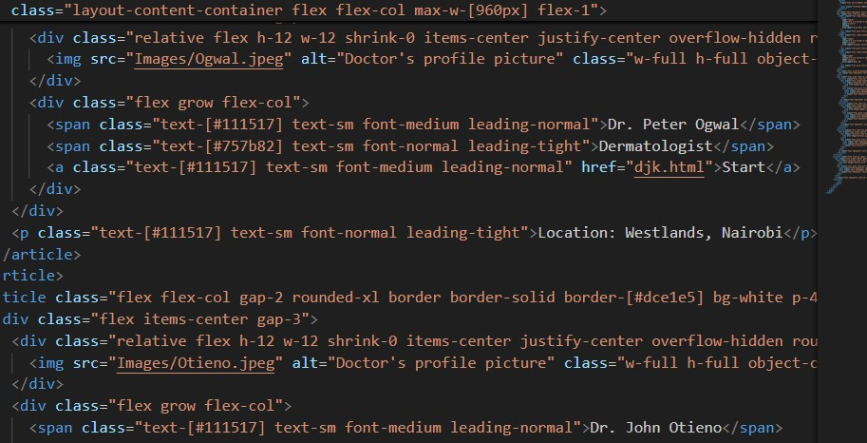
3. Consultation page  
   The interface of the consultation page, which was made with HTML and CSS, is seen in the screenshot below.  
   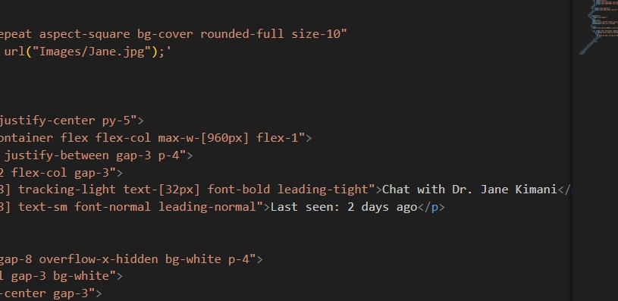

## 5.3 System Testing

This section considers the functionality of the system and verifies whether the system meets the requirements. Testing is, therefore, crucial to discover flaws and problems in a system, solve them, and ensure that the system works for its purpose.

### 5.3.1 Blackbox Testing

Black Box Testing was conducted to test the usability of the system from the user's perspective. The development aimed at an interactive user interface with a colour scheme based on healthcare. Reports were included to represent the working of the system clearly and the interface was designed to be simple and user-friendly.

### 5.3.1 Functionality Testing

The system fulfils all the functional requirements by providing a facility for patients and doctors to register their details and ensuring that access is only granted through a secure login to authorized users. It also allows users to log out successfully. Also, the admin can approve or delete accounts created by the patients and doctors. All user-input information is safely saved in the local MySQL database.

### 5.3.1 Unit Testing

Verifying the functionality of individual units or components of a system, usually at the function or method level, is the main goal of unit testing, a sort of software testing.

## 5.4 Test Cases

Table 1 Test Cases

|  |  |  |  |
| --- | --- | --- | --- |
| **Test Case** | **Description** | **Test Data** | **Expected Outcome** |
| User registration | User can register | User details | Successfully registered |
| User log in | User can log in | Username, password | Log in successfully |
| Patient choice | The patient picks a doctor of choosing | doctor | Select Doctor |
| Admin modification | Admin can delete and edit doctor accounts | Doctor account | Edited |
| Patient payment | Access amount due to make payment | Mpesa till number,  Amount due | Amount to be paid |

## 5.5 Test Results

Table 2 Test Results

|  |  |  |  |  |  |
| --- | --- | --- | --- | --- | --- |
| **Test Case** | **Description** | **Test Data** | **Expected Outcome** | **Actual Result** | **Verdict (PASS / FAIL)** |
| User registration | User can register | User details | Successfully registered | Successful registration | PASS |
| User log in | User can log in | Username, password | Log in successfully | Successful login | PASS |
| Patient choice | The patient picks a doctor of choosing | doctor | Select Doctor | Selection  successful | PASS |
| Admin modification | Admin can delete or edit doctor accounts | Doctor account | Edited or deleted | Account edited | PASS |
| Patient payment | Access amount due to make payment | Mpesa till number,  Amount due | Amount to be paid | Amount paid | PASS |

# Chapter 6: Conclusions and Recommendations for Future Work

## 6.1 Conclusions

This is a project that enhances doctor-patient connections in Kenya through an improved web-based application for accessing emergency ambulance contacts and doctor consultations. The aim is to improve health outcomes through accessibility and health awareness. Use of Agile methodology and OOAD ensured the delivery of an effective workflow. Programs like Canva, XAMPP, and Visual Studio made development easier. User-friendliness, functionality, and security were assured through thorough testing.

## 6.2 Recommendations

It is recommended that doctors be certified by the Kenya Medical Association to avoid complications arising from misdiagnosis, which may lead to litigations; that the system be accessed using an active internet connection; and that caution be taken while processing payments to avoid double charging of patients due to mismanagement.

## 6.3 Future work

Future healthcare websites may feature hospital booking systems, real-time video consultations with doctors, or Mpesa payment confirmation. With video calls, convenience would increase since any person would have an easy way to get medical advice quickly without necessarily having to travel. A booking system would speed up appointments by letting patients choose timeslots and receive immediate confirmations. These changes would advance healthcare delivery and convenience.

# References

*Africa health workforce investment forum*. (2024, May 6). World Health Organization (WHO). <https://www.who.int/news-room/events/detail/2024/05/06/default-calendar/africa-health-workforce-investment-forum>

*Google scholar*. (n.d.). Google Scholar. <https://scholar.google.com/scholar?hl=en&as_sdt=0%2C5&q=long+patient+test+results+time&btnG=>

*Just a moment..*. (n.d.). ResearchGate | Find and share research. <https://www.researchgate.net/publication/365806651_Healthcare_Accessibility_in_Developing_Countries_A_Global_Healthcare_Challenge>

*Kenyanest.com*. (n.d.). kenyanest.com. <https://kenyanest.com/top-8-best-medical-and-healthcare-apps-in-kenya/>

Kipkoech, B. (2019, March 13). *List of medical and healthcare apps you should have in Kenya*. Victor Matara. <https://victormatara.com/list-of-medical-and-healthcare-apps-in-kenya/>

*Need, demand, supply in health care: Working definitions, and their implications for defining access*. (n.d.). Cambridge Core. <https://www.cambridge.org/core/journals/health-economics-policy-and-law/article/need-demand-supply-in-health-care-working-definitions-and-their-implications-for-defining-access/DCA6075231537BB4EFC57793B33879F0>

*Sustainable development goals | United Nations development programme*. (n.d.). UNDP. <https://www.undp.org/sustainable-development-goals/good-health>

# Appendix A: Gantt Chart

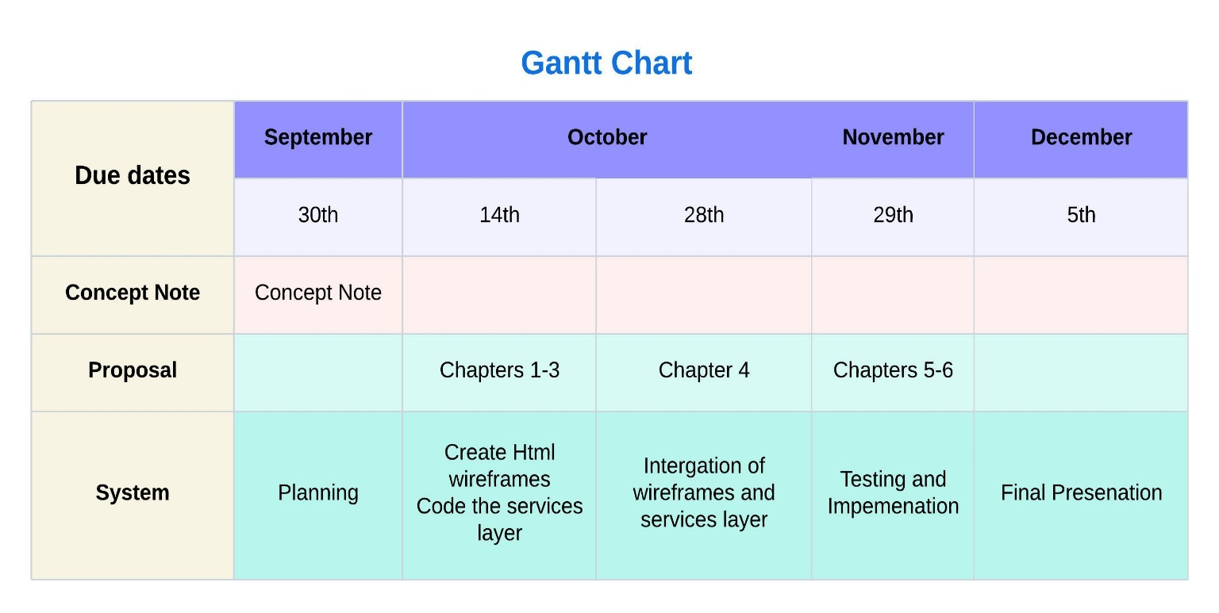

Appendix 1 Gantt Chart

# Appendix B: Marking Guide